

CENTRE OF DEVELOPMENT AND ADVANCE COMPUTING, HYDERABAD

Documentation On

**“ONLINE SHOPPING SYSTEM”**

PG-DAC MARCH 2023

*Submitted By:*

**Group No: 10**

**Sandeep Kumar Singh - 230350320093**

**Sumit Kumar Dubey - 230350320092**

**Sanket Shivprasad Sarda - 230350320096**

**Sanket Sudarshan Chaugule - 230350320097**

**Vishal Madhukar Sangle - 230350320095**

**Mr. Sharan Mr. Vamsikrishna Kotapati**

Centre Coordinator Project Guide

# Table of Contents

1. Introduction 3

Document Purpose 3

Problem Statement 3

Scope of Project 3

Aim & Objectives 4

1. Overall Description 4

Benefits of Online Shopping System 4

User and Characteristics 4

Operating Environment 5

Design and Implementation Constraints 5

1. Requirements Specification 5

External Interface Requirements 5

Functional Requirements 6

Non-Functional Requirements 7

1. System Diagram 8

Activity Diagram 8

Use Case Diagram 9

ER Diagram 10

Class Diagram 11

1. Table Structure 12

Restaurant 13

Customer 14

restaurant_manager 15

orders 15

order_item 16

delivery_person 16

food_item 17

food_type 17

payment 17

1. Screenshots 18
2. Conclusion 30
3. Future Scope 31
4. References 32

2

# Introduction:

Online Shopping is based on a concept of making Product orders from customers to providers. The purpose of this system is basically connect the providers and customers in a platform where provider can increase their sell fast and customers can buy their desire product from home which will also consume less time and make the life easier. On a web-based marketplace, each small business receives a greater exposure, than when operating alone, which in turn provides a greater opportunity for increased sales. Besides, customers also want many options before buying any product and want to order from home. So eventually, providers can reach to the bigger number of customers instantly from anywhere.

This project is a web-based shopping system for an existing shop. The "Online Shopping System" has been developed to override the problems prevailing in the practicing manual system. This software is supported to eliminate and in some cases reduce the hardships faced by the existing system. It can assist the business to concentrate on their other activities rather concentrate on the record-keeping by managing the information of Customers, Orders, Addresses, Products. Thus, it will help organizations in better utilization of resources. It will also help the business to reach large number of customers.

In the new normal situation around the world, online Shopping is getting huge attention as it helps people to get the essentials without stepping outside and also helps in social distancing. Acceptance of online Shopping platforms in India has increased in recent years, owing to rising awareness about the convenience of the process, digital literacy, and internet penetration across the country. Growing interest by consumers to point and click their way through nearly all aspects of daily life has fueled the internet economy to develop services and sell products online even in areas that were once the sole domain of traditional businesses, such as Shopping stores. Some of the reasons why an increasing number of consumers buy Products online are common to all internet purchases, including better prices, larger selection, convenience, and time savings. Home delivery for various reasons such as physical disability, the need to care for small children, the lack of adequate or convenient transportation, a busy lifestyle, and now the need for social distancing. Buying products online unchains the consumers from physically driving to and shopping in traditional stores.

## Document Purpose:

This document details the software requirements for the E-commerce website. It defines what the problem is and what problems a complete solution has to solve. The purpose of this software requirements specification is to verify that all the specifications are correct and verified. This document also serves to ensure that the software is traceable throughout its software development life cycle.

The objective of this project is to develop a general purpose e-commerce store any products can be bought from the comfort of home through the Internet .

## Problem Statement:

Online shoppers face number of challenges. The major challenge is lack of handy experience in consumer demands. Online market has developed its space in virtual world but is this market worth for all kinds of products specially the perishable products.

## Scope of Project:

* Online Shopping is a platform for a Products to enhance their sale. In this application the customer can login, select products, quantity and proceed towards confirm order. After confirming the order Products provider will get a notification of order. Payment method will be online through payment Gateway. This website will give the Customer a greater exposure to their products at their Ease of Comfort. After payment Admin will Authorize the Products and assign for delivery to Delivery Person.
* To utilize resources in an efficient manner by increasing their productivity through automation.
* The system generates types of information that can be used for various purposes.

## Objectives:

The main objective of the Project on Online Shopping System is to manage the details of Products, Customer, delivery person, Admin, Order, cart, payment. It manages all the information about Products. The project is totally built at admin end and thus only the administrator is guaranteed the access. The purpose of the project is to build an application program to reduce the manual work for managing the products, Customer, Address and Order. It tracks all the details of the Order, Product.

# Overall Description:

## Benefits of Online Shopping System:

* + This online Shopping system is fully functional and flexible.
  + It is very easy to use.
  + It saves a lot of time, money and labor.
  + Eco-friendly: The monitoring of the product orders and Product management and the overall business becomes easy and includes the least of paper work.
  + The application acts as an office that is open 24/7.
  + It increases the efficiency of the management at offering quality services to the customers.
  + It provides custom features development and support with the application.

**User classes and characteristics:**

There will be two types of users in the system there are Shop owner and customers. First of all, the Shop owner will have control and knowledge over the entire system. They can add and remove products as well. The Shop owner got access to the shop information and has privilege to update it as well. The Shop owner will be able to see shops current order request and can accept and cancel the request and also, they can see all order information. Along with ordering products online, the customers can view their personal information and update it in need. They can view which orders are pending and which are received.

Shop owner:

* Shop owner can login to the system.
* View the list of all products.
* Add new Product.
* Delete product details.
* Update product details.
* Assign order to delivery Person.
* View the all pending orders and completed orders.

4

Customer:

* Customer can login to the system.
* View his/her details.
* Check all product details.
* Customer can select product and enter the quantity of product.
* Add product in cart and then place then place the order.
* View Order list pending/delivered.
* Update their personal credentials.
* Does the online payment.

Visitor:

* Visitor can sign up then only he can buy products.

## Operating Environment:

Server Side:

**Processor**: Intel® Xeon® processor 4500 series

**HDD**: Minimum 700GB Disk Space

**RAM**: Minimum 4GB **OS:** Windows 10 **Database**: MySQL

Client Side (minimum requirement):

**Processor**: Intel i3 Core

**HDD**: Minimum 4MB Disk Space

**RAM**: Minimum 512MB

**Web Browser:** Google Chrome or any compatible browser

**OS**: Any

## Design and Implementation Constraints:

* + The application will use ReactJs, NodeJs, Spring boot and CSS as main web technologies.
  + HTTP protocols are used as communication protocols.
  + Several types of validations make this web application a secured one and SQL Injections can also be prevented.
  + Since Online Shopping System is a web-based application, internet connection must be established.
  + The Online Shopping System will be used on PCs and Mobile phone via internet or intranet in any web browser.

# Specific Requirement:

## External Interface Requirements:

User Interface:

* + All the users will see the same page when they enter in this website. This page shows all login option.
  + Login page asks the users email Id and a password.

5

* + After being authenticated by correct email id and password, user will be redirect to their corresponding profile where they can do various activities.
  + The user interface will be simple and consistent, using terminology commonly understood by intended users of the system. The system will have simple interface, consistence with standard interface, to eliminate need for user training of infrequent users.

Application Interfaces:

* + OS: Windows 10
  + Web Browser: The system is a web-based application; clients need a modern web browser such as Microsoft Edge, Mozilla Firebox, Internet Explorer, Opera, and Chrome. The computer must have an Internet connection in order to access the website.

Communications Interfaces:

* + This system uses communication resources which includes but not limited to, HTTP protocol for communication with the web browser and web server and TCP/IP network protocol with HTTP protocol.
  + This application will communicate with the database that holds all the booking information. Users can contact with server side through HTTP protocol by means of a function that is called HTTP Service. This function allows the application to use the data retrieved by server to fulfill the request fired by the user.

## Functional Requirement:

This section provides requirement overview of the system. Various functional modules that can be implemented by the system are->

## Product Catalog:

* + - Any Customer will be able to view product.
    - Catalog maintained by Shopper.

## Inventory:

* + - Shopper will be able request to add new product to product catalog maintained by system.
    - Shopper will be able to add or remove products from product List.
    - Product listing will be provided based on their shops.

## Shopping Cart:

* Consumer will be able to add or remove products from shopping cart. System will maintain shopping cart for each consumer to maintain list of items selected by him/her.
* Consumer will be able view all items from shopping cart.
* Shopping Cart will present product details, number of items of product selected by consumer with price and total.

## Order Processing:

* Registered Customer will be able place an order with the help of shopping cart maintained by system. Registered Customer will be able to cancel placed order.
* Registered customer gets orders history. Registered customer can get details of order from orders been placed.
* Shopper will be able to get details of orders of a particular Customer. Shopper will be able to cancel, reject or approve orders that have been placed by consumer due to some policies of Business and later will assign the order to the delivery person.

6

## Payment Processing:

* Consumer will be provided options for payment such as through COD, UPI or other online payment options. Consumer will ask to submit their payment related information. Consumer will be redirected to payment gateway for secure payment transaction. On successful payment processing using payment gateway system will notify consumer about transaction and order placement status.

## Customer Support:

* Customer will be able to update his/ her personal information.
* Shopper will be able to monitor daily online shopping business activities using their personalized dashboard.
* Customer will be able get their purchase related information using Customer Dashboard.

## Non-Functional Requirement: Security:

* + Registered Customer will allow placing an order.
  + System will internally maintain secure communication channel between Servers (Web Servers, App Servers, database Server).
  + Sensitive data will be always encrypted across communication.

## Reliability:

* The system will backup business data on regular basis and recover in short time duration to keep system operational Continuous updates are maintain, continues Administration is done to keep system operational.
* During peak hours system will maintain same user experience by managing load balancing.

## Availability: Accessibility:

* uptime: 24* 7 available
* Only registered customer will be able to place an order after authentication.
* Shoppers will be able to see their product, delete, update, and add new products.

## Efficiency and Maintainability:

* + Page loads should be returned and formatted in a timely fashion depending on request being made.
  + Administrators have ability to see all orders and maintain products.
  + Commercial database software will be used to maintain System data Persistence.
  + A readymade Web Server will be installed to host online shopping portal (Web Site) to management server capabilities.

## Modularity:

* These modules will be loosely coupled and highly cohesive.
* System will contain CRM, Inventory, shopping cart, order processing, payment processing, and Delivery modules.

7

# System Design:

## Activity Diagram:

**Figure 1: Activity Diagram**

**Admin And Customer**

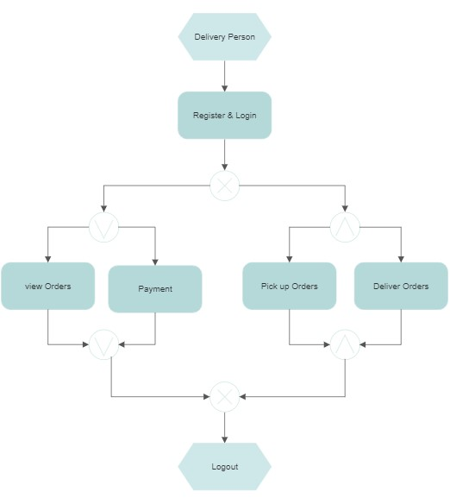

**Figure 2: Activity Diagram**

**Delivery person**

## Use Case Diagram:

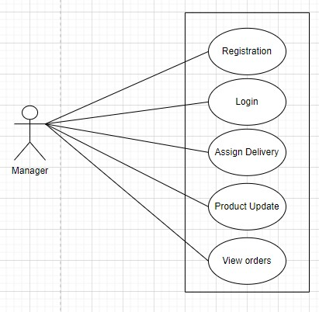

**Figure 3: Use Case Diagram for Shopkeeper**

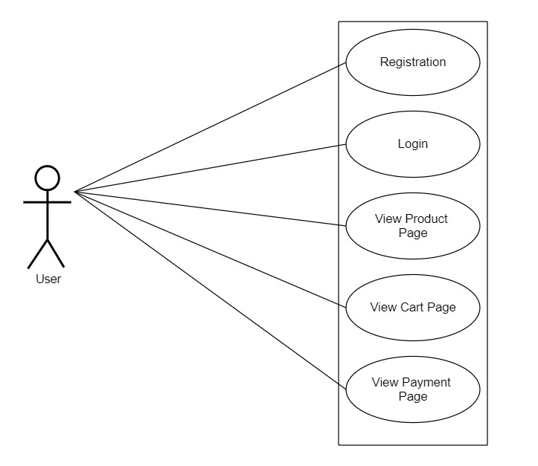

## Figure 4: Use Case Diagram for Customer

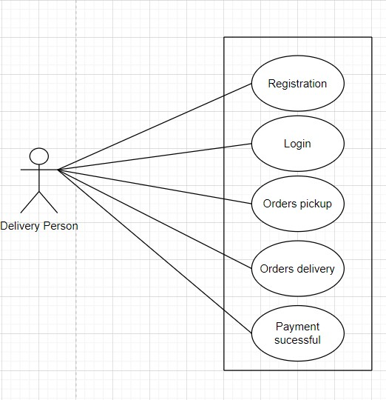

## Figure 5: Use Case Diagram for Delivery Person

## 

## ER Diagram:

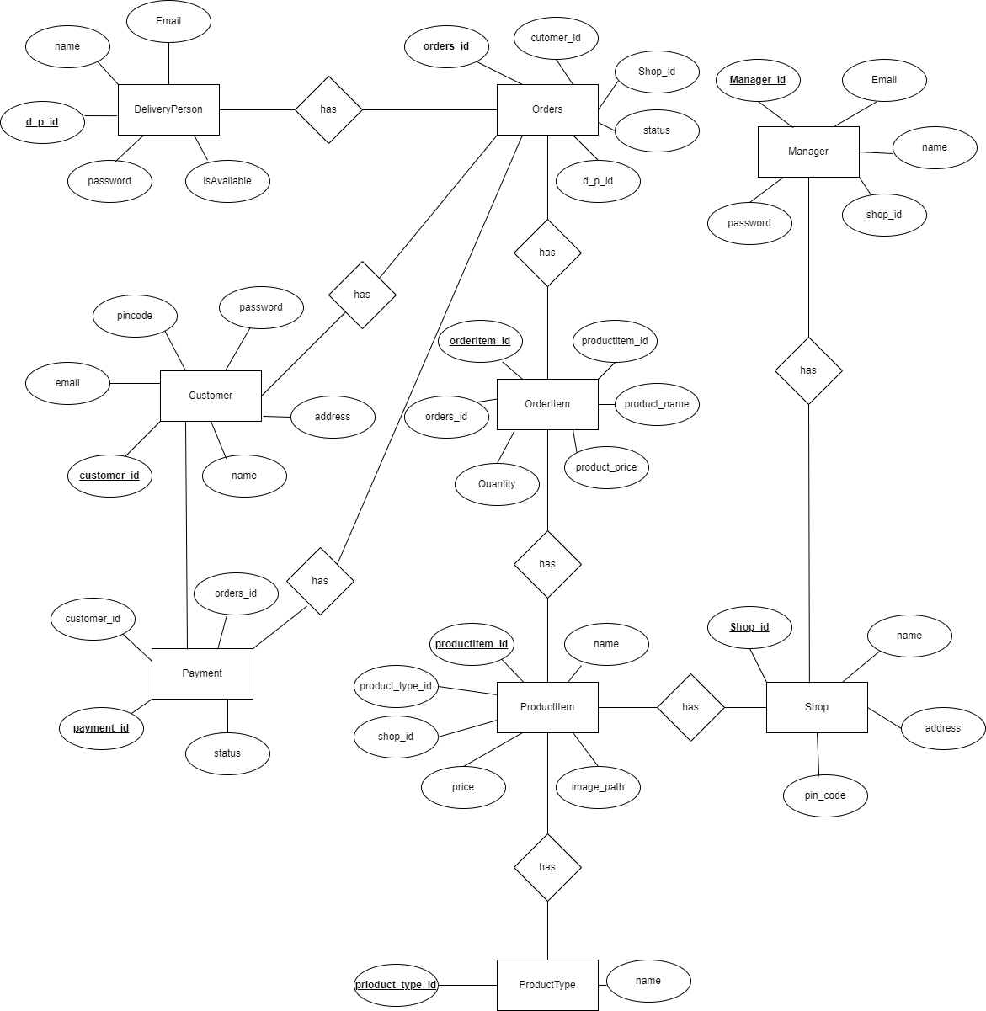

**Figure 6: E-R Diagram**

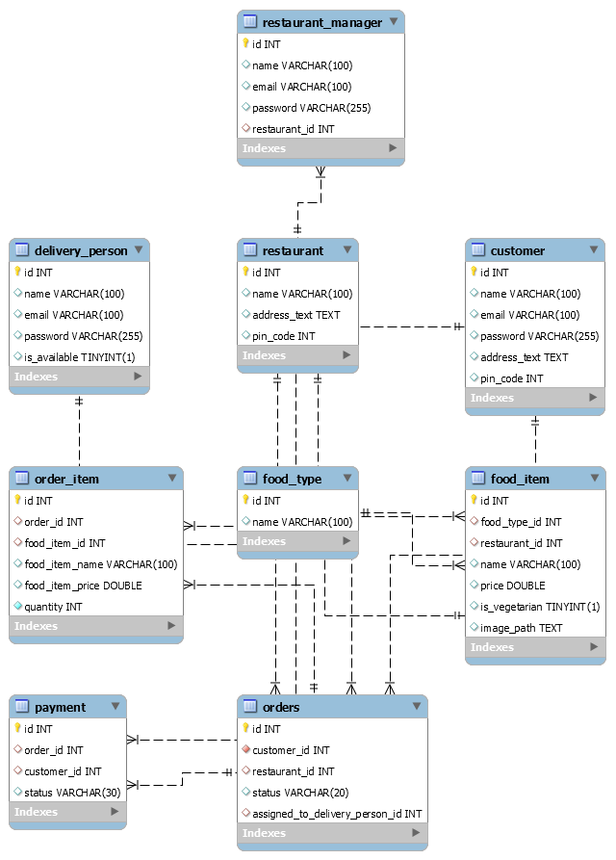

**Figure 7: Class Diagram**

# Table Structure:

# Customer:

|  |  |  |  |  |  |
| --- | --- | --- | --- | --- | --- |
| **Field** | **Type** | **Null** | **Key** | **Default** | **Extra** |
| id | int | NO | PRI | NULL | auto_increment |
| name | varchar(100) | YES |  | NULL |  |
| email | varchar(100) | YES |  | NULL |  |
| password | varchar(255) | YES |  | NULL |  |
| address_text | text | YES |  | NULL |  |
| pin_code | int | YES |  | NULL |  |

# Restaurant_manager :

|  |  |  |  |  |  |
| --- | --- | --- | --- | --- | --- |
| **Field** | **Type** | **Null** | **Key** | **Default** | **Extra** |
| id | int | NO | PRI | NULL | auto_increment |
| name | varchar(100) | YES |  | NULL |  |
| email | varchar(100) | YES |  | NULL |  |
| password | varchar(255) | YES |  | NULL |  |
| address_text | text | YES |  | NULL |  |
| pin_code | int | YES |  | NULL |  |

# Delivery_person :

|  |  |  |  |  |  |
| --- | --- | --- | --- | --- | --- |
| **Field** | **Type** | **Null** | **Key** | **Default** | **Extra** |
| id | int | NO | PRI | NULL | auto_increment |
| name | varchar(100) | YES |  | NULL |  |
| email | varchar(100) | YES |  | NULL |  |
| password | varchar(255) | YES |  | NULL |  |
| is_vegetarian | tinyint(1) | YES |  | NULL |  |

# 

# Orders :

|  |  |  |  |  |  |
| --- | --- | --- | --- | --- | --- |
| **Field** | **Type** | **Null** | **Key** | **Default** | **Extra** |
| id | int | NO | PRI | NULL | auto_increment |
| customer_id | int | NO | MUL | NULL |  |
| restaurant_id | int | YES | MUL | NULL |  |
| status | varchar(20) | YES |  | NULL |  |
| assigned_to_delivery_person_id | int | YES | MUL | NULL |  |

# order_item :

|  |  |  |  |  |  |
| --- | --- | --- | --- | --- | --- |
| **Field** | **Type** | **Null** | **Key** | **Default** | **Extra** |
| id | int | NO | PRI | NULL | auto_increment |
| order_id | int | YES | MUL | NULL |  |
| food_item_id | int | YES | MUL | NULL |  |
| food_item_name | varchar(100) | YES |  | NULL |  |
| food_item_price | double | YES |  | NULL |  |
| quantity | int | NO |  | NULL |  |

# food_item :

|  |  |  |  |  |  |
| --- | --- | --- | --- | --- | --- |
| **Field** | **Type** | **Null** | **Key** | **Default** | **Extra** |
| id | int | NO | PRI | NULL | auto_increment |
| food_type_id | int | YES | MUL | NULL |  |
| restaurant_id | int | YES | MUL | NULL |  |
| name | varchar(100) | YES |  | NULL |  |
| price | double | YES |  | NULL |  |
| is_vegetarian | tinyint(1) | YES |  | NULL |  |
| image_path | text | YES |  | NULL |  |

# food_type :

|  |  |  |  |  |  |
| --- | --- | --- | --- | --- | --- |
| **Field** | **Type** | **Null** | **Key** | **Default** | **Extra** |
| id | int | NO | PRI | NULL | auto_increment |
| name | varchar(100) | YES |  | NULL |  |

# restaurant :

|  |  |  |  |  |  |
| --- | --- | --- | --- | --- | --- |
| **Field** | **Type** | **Null** | **Key** | **Default** | **Extra** |
| id | int | NO | PRI | NULL | auto_increment |
| name | varchar(100) | YES |  | NULL |  |
| address_text | text | YES |  | NULL |  |
| pin_code | int | YES |  | NULL |  |

# 

# payment :

|  |  |  |  |  |  |
| --- | --- | --- | --- | --- | --- |
| **Field** | **Type** | **Null** | **Key** | **Default** | **Extra** |
| id | int | NO | PRI | NULL | auto_increment |
| order_id | int | YES | MUL | NULL |  |
| customer_id | int | YES | MUL | NULL |  |
| status | varchar(30) | YES |  | NULL |  |

# 

# 

# Screenshots:

Home page

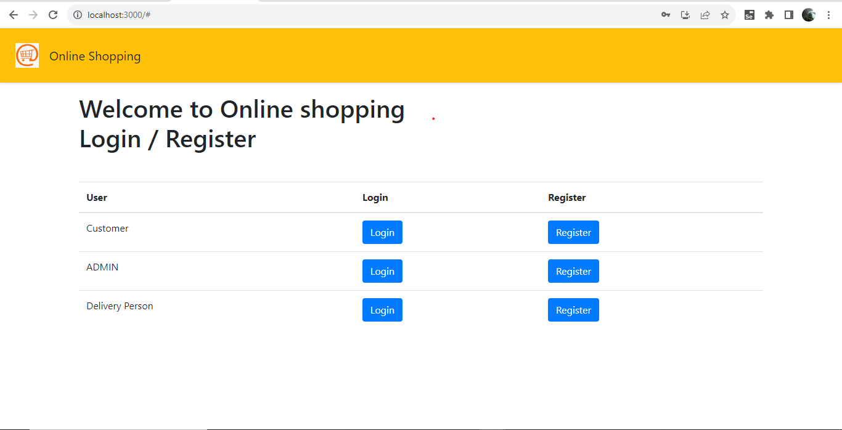

**CUSTOMER / USER :**

Customer Registration

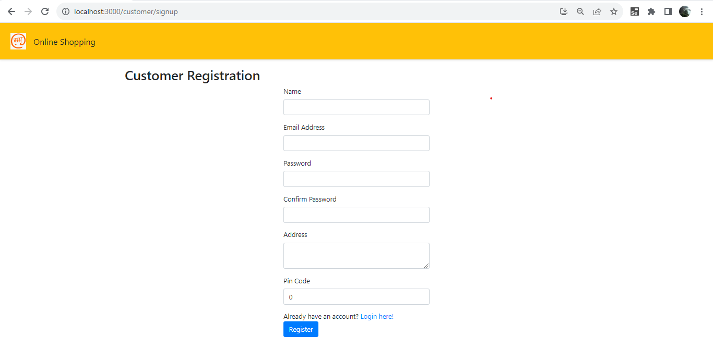

Customer Registered need to Login

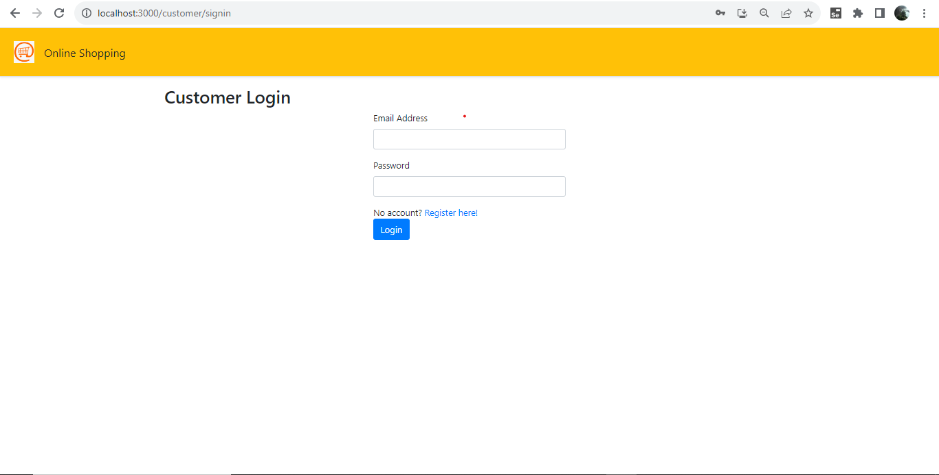

Customer Logged in

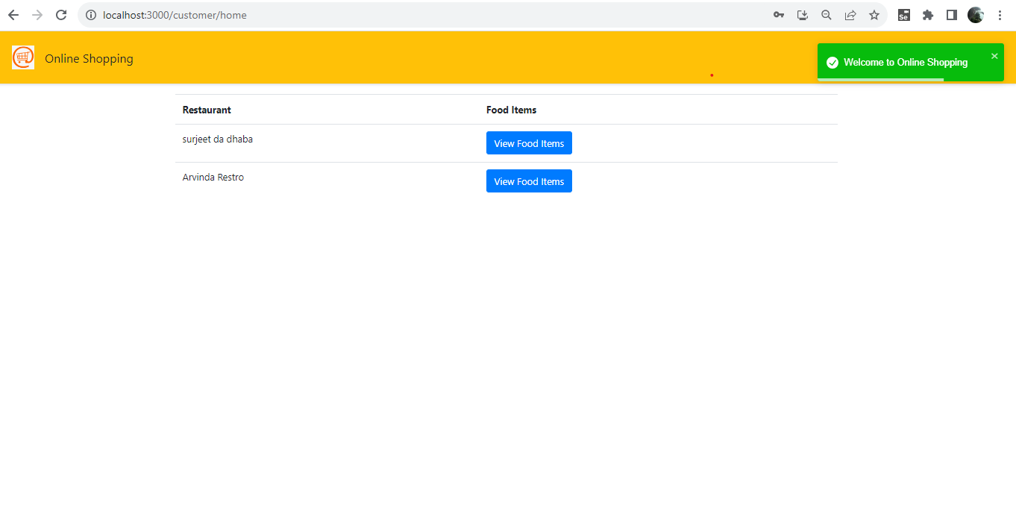

Customer views food items of restaurants

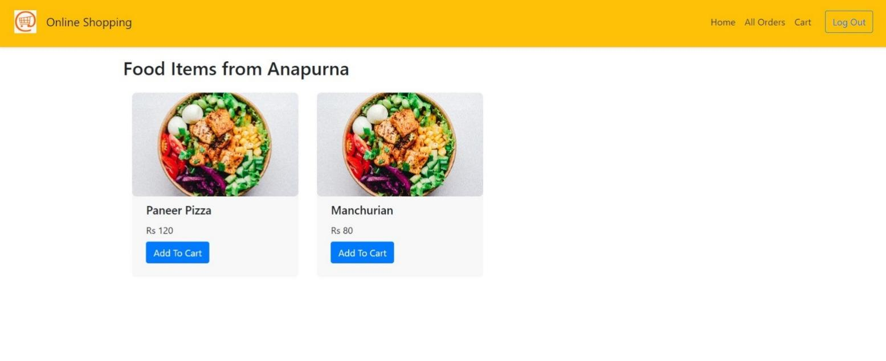

Food added to Cart

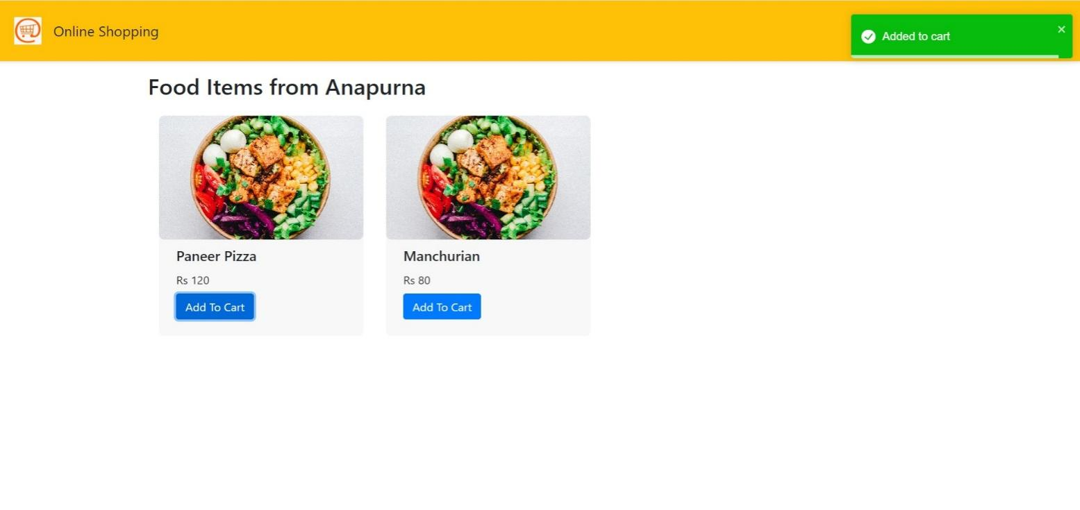

Customer Views Cart

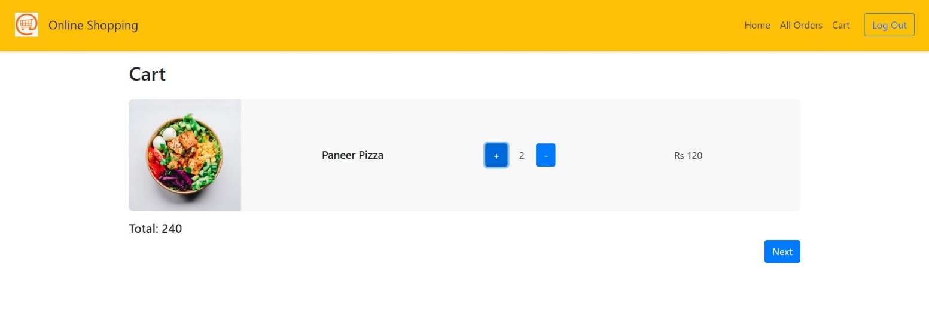

Customer Add/update Address

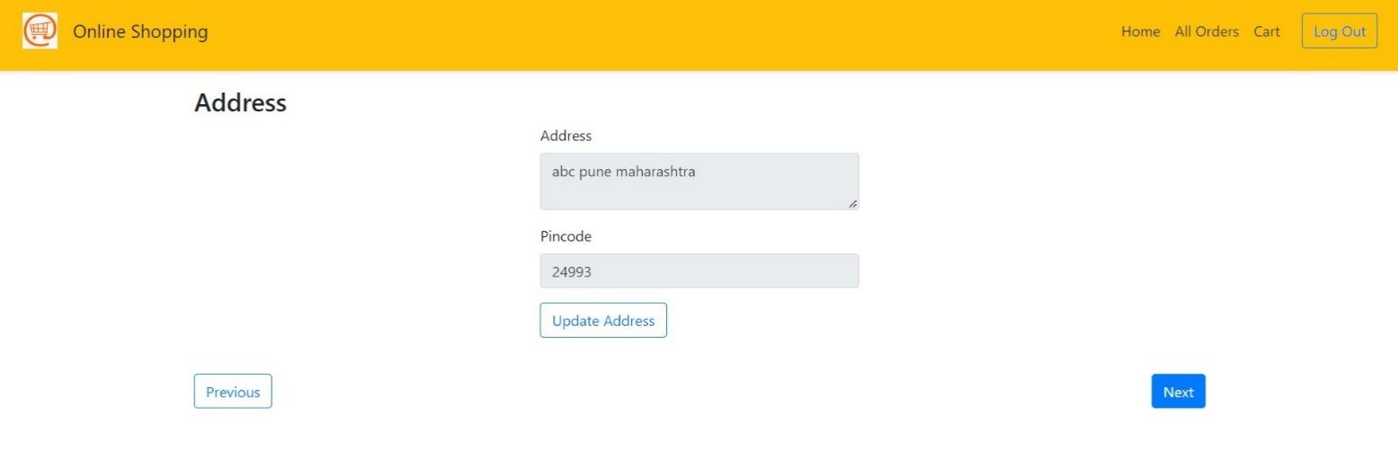

Customer Then directed to the payment

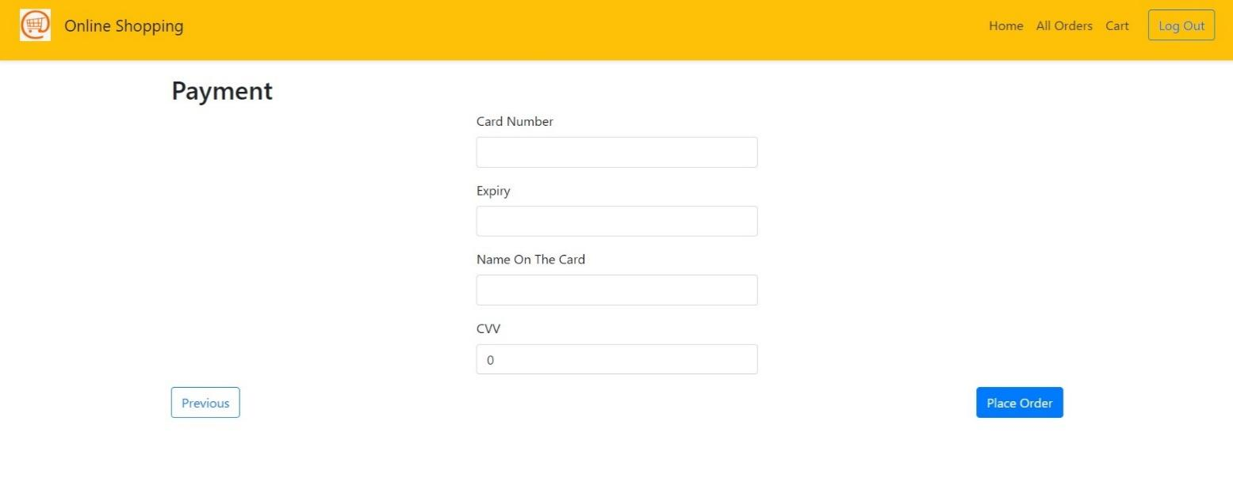

Customer paid For Order Successfully

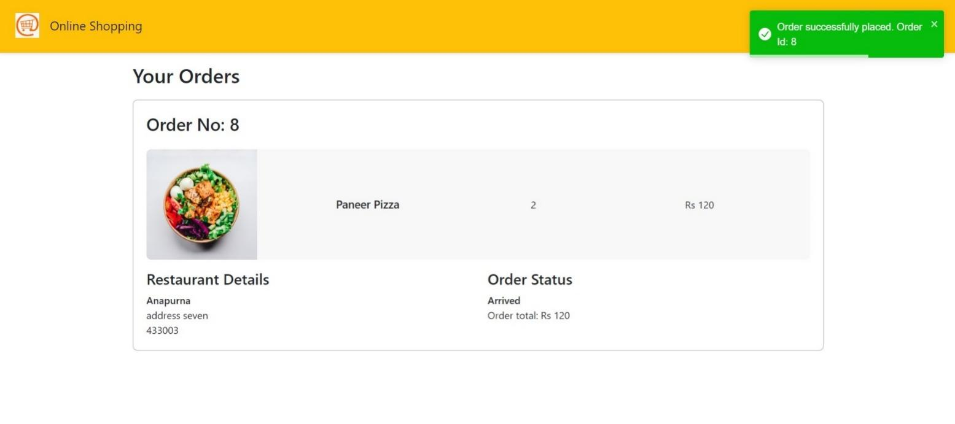

**MANAGER/ADMIN :**

Manager Registration

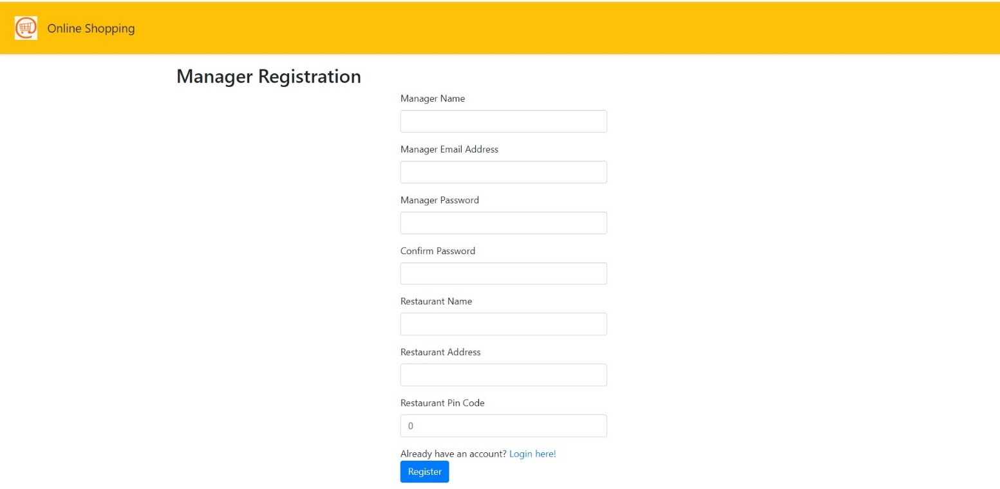

Manager Login

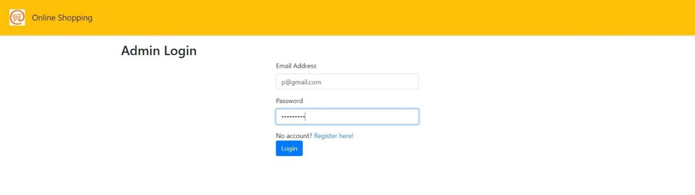

Manager Logged in

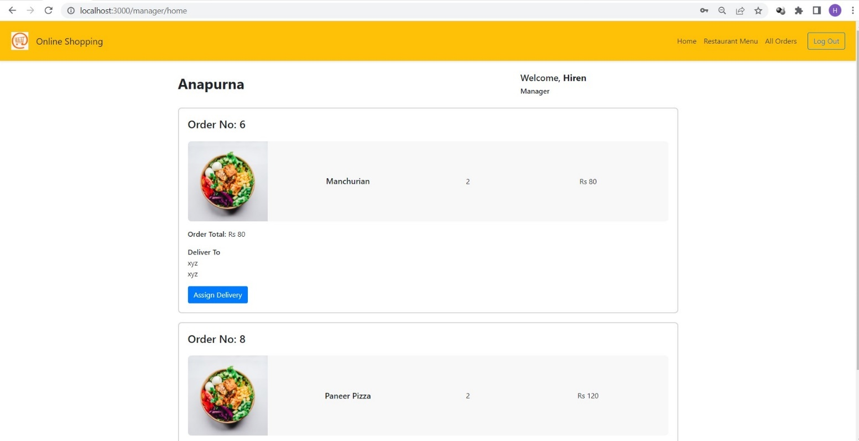

Manager can Assign the Order to the Delivery Person

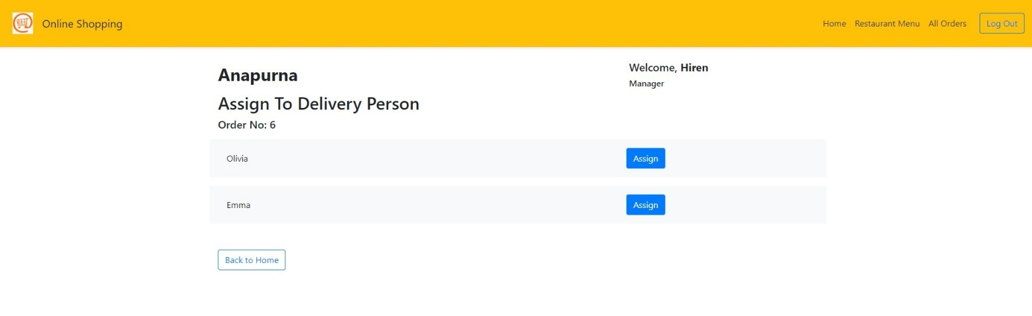

Manager Assigns The Order

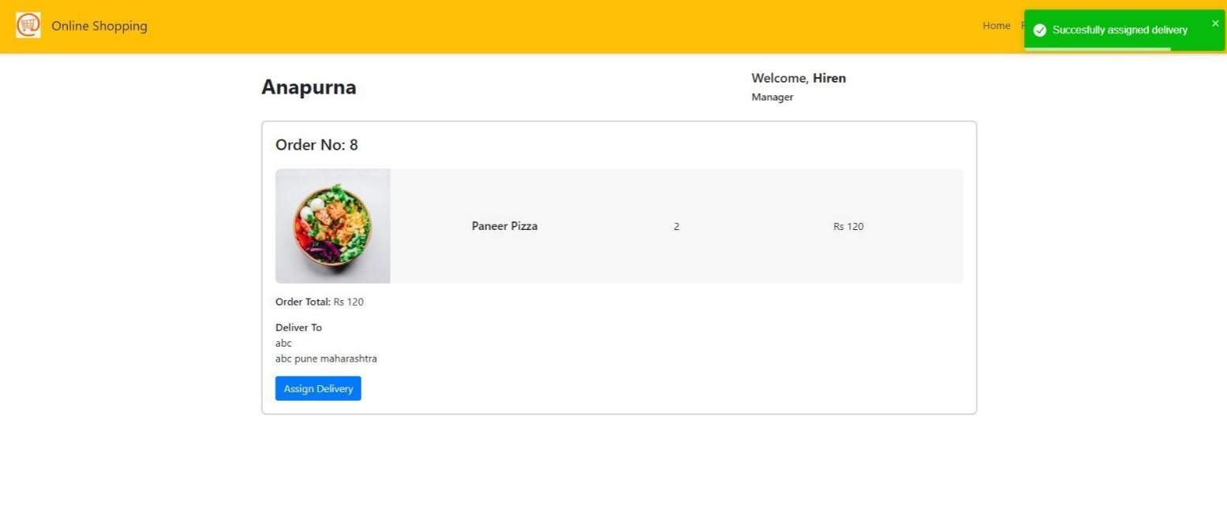

Manager can see all users All Orders for his/her restaurant via All Orders

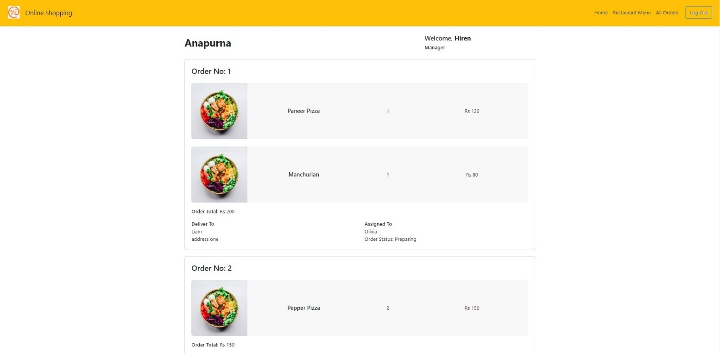

Manager can see and add/edit Restaurant menu food items

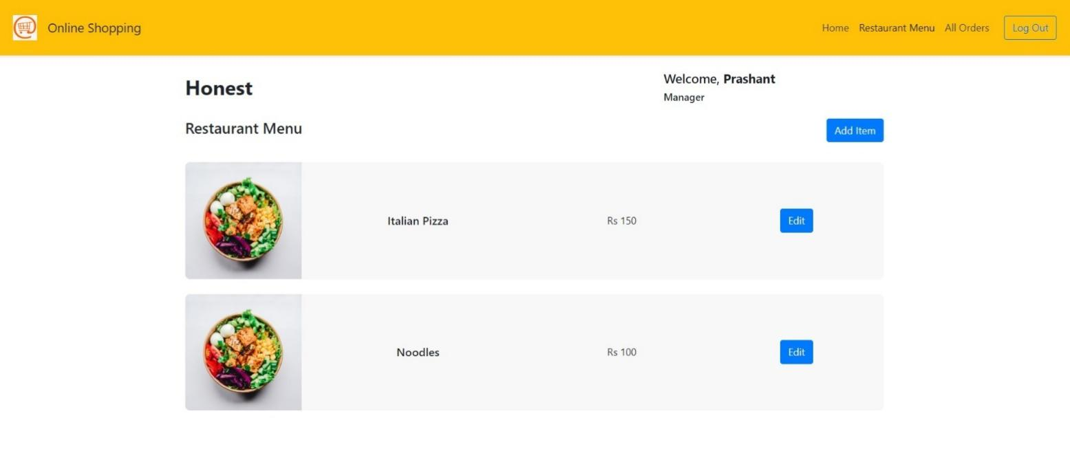

Manager Adds Food Item to restaurant

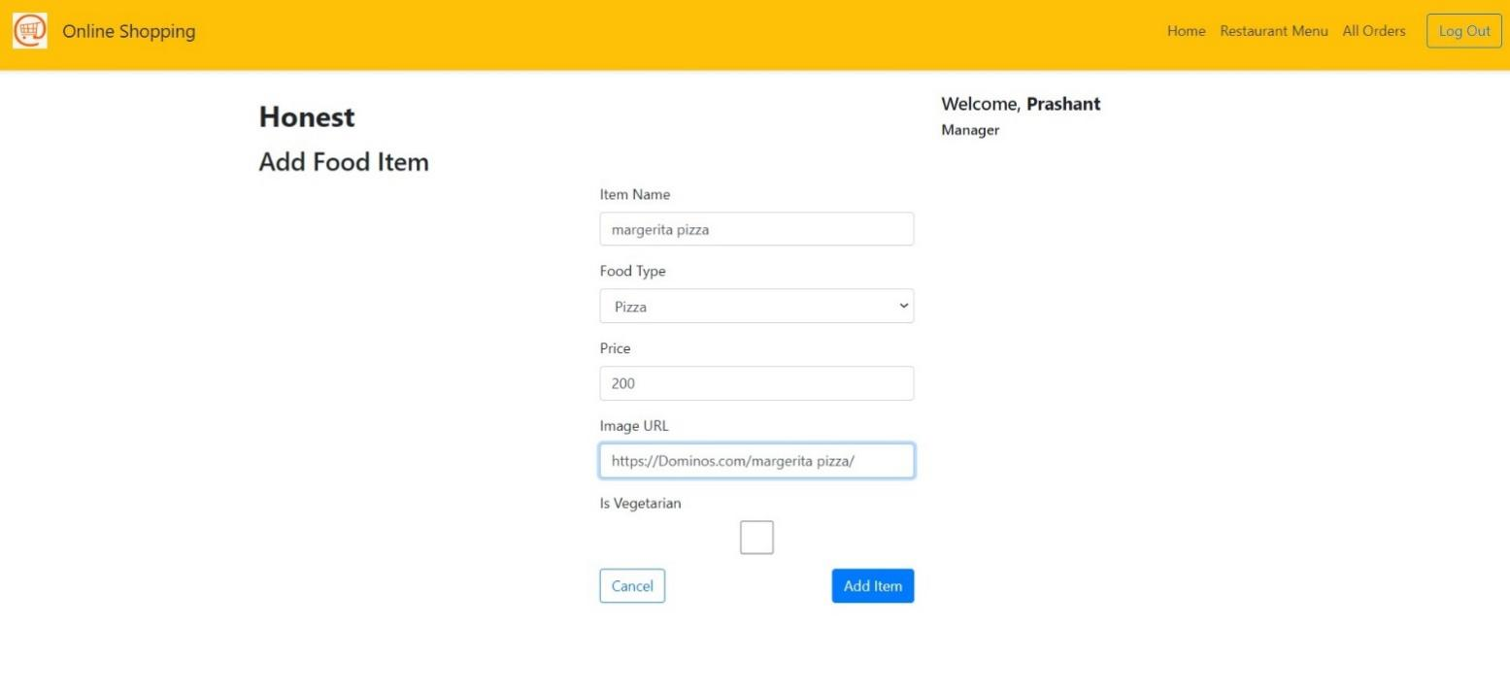

**Delivery Person :**

Delivery Person Sign Up

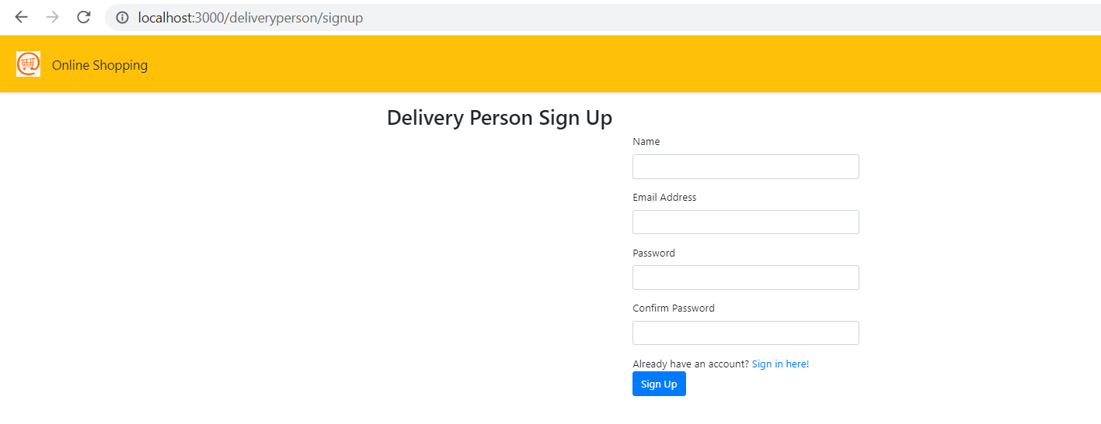

Delivery Person Signed in

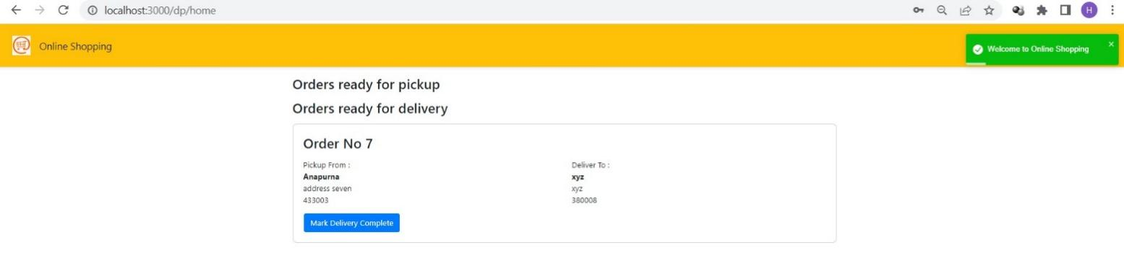

Orders Viewed By Delivery Person via view all orders

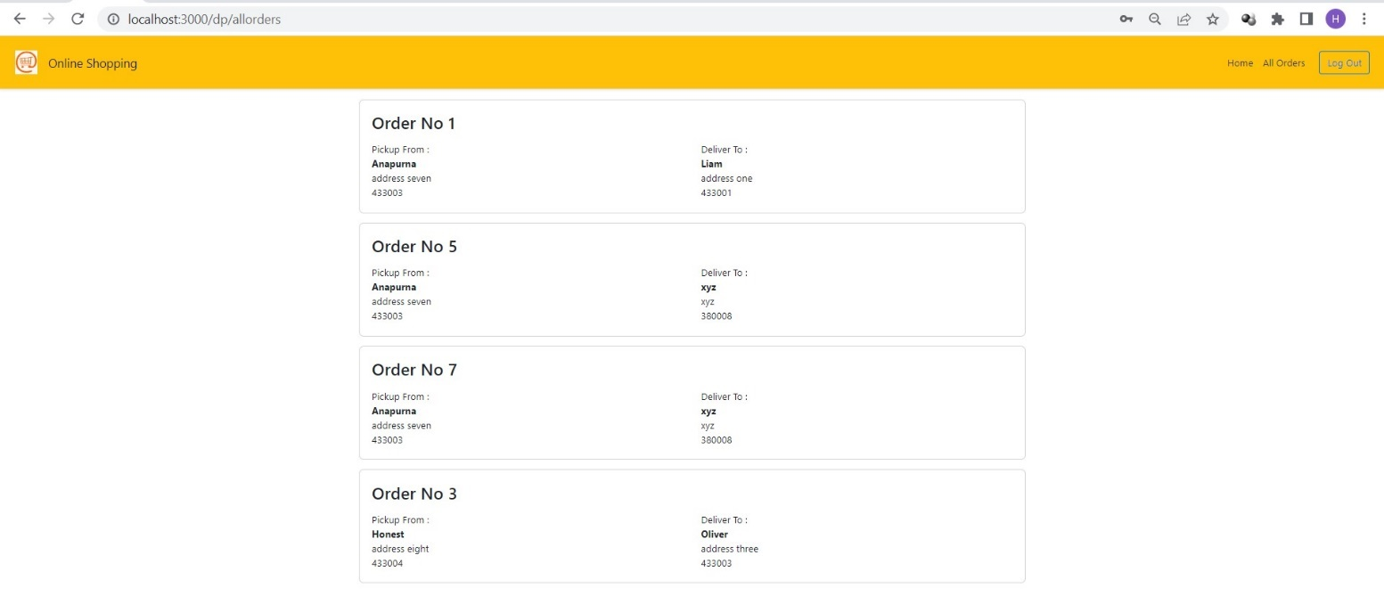

Delivery completed via Delivery Person

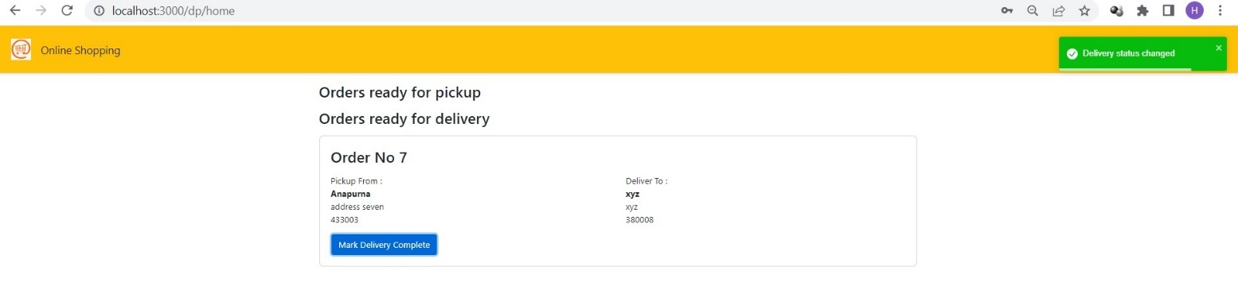

# Conclusion:

Technology has made significant progress over the years to provide consumers a better online shopping experience and will continue to do so for years to come. With the rapid growth of

products and brands, people have speculated that online shopping will overtake in-store

shopping. While this has been the case in some areas, there is still demand for brick and mortar stores in market areas where the consumer feels more comfortable seeing and touching the product being bought. However, the availability of online shopping has produced a more

educated consumer that can shop around with relative ease without having to spend a large amount of time. In exchange, online shopping has opened up doors to many small retailers that would never be in business if they had to incur the high cost of owning a brick and mortar store. At the end, it has been a win-win situation for both consumer and sellers

# Future Scope:

The internet, its popularity, and technological developments are a good mixture for any business. It is an undeniable fact regarding the future of online Shopping System. It has not been a very long time since the industry has turned to the internet way of doing things.

Payment gateway is in our future scope we are going to provide many options for payment. We will permit multiple payment modes that include UPI, cash on delivery, card on delivery, net banking, EMIs on credit or debit card and pay-later credit facility.

# References:

Google : [www.google.com](http://www.google.com),

Geeks for Geeks : <https://www.geeksforgeeks.org>,

W3Schools : <https://www.w3schools.com/>,

Javatpoint : <https://www.javatpoint.com/>,